Linux Activity 5

Task 1: Create Aliases

Create aliases for the following commands:

1. “ls -al” 🡪 “ll”

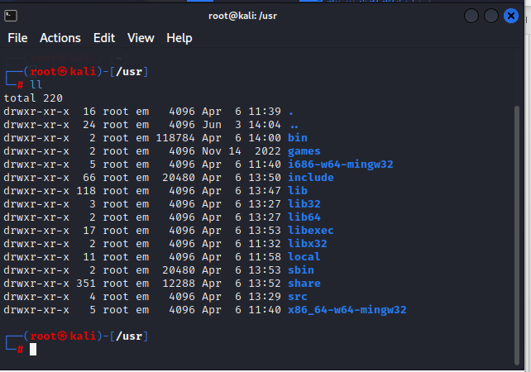

1. “cp -r” 🡪 “copy”



Task 2: Use man and help

Provide the following information:

1. How do you access the manual page for the “grep” command?

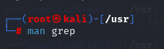

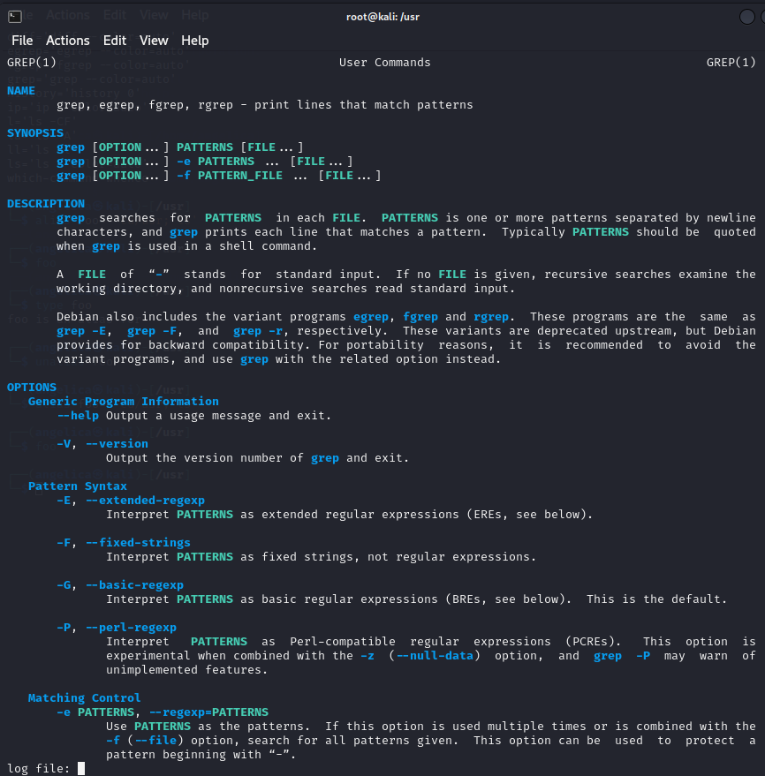

1. What command can you use to find out more about a shell command?

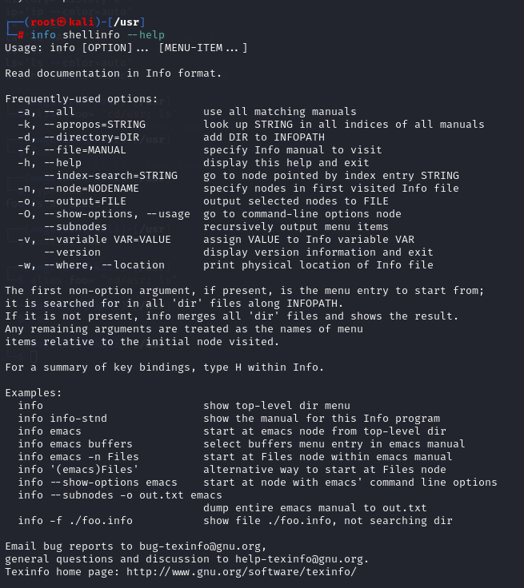

1. What command can you use to list all available options and commands for the “tar” command?



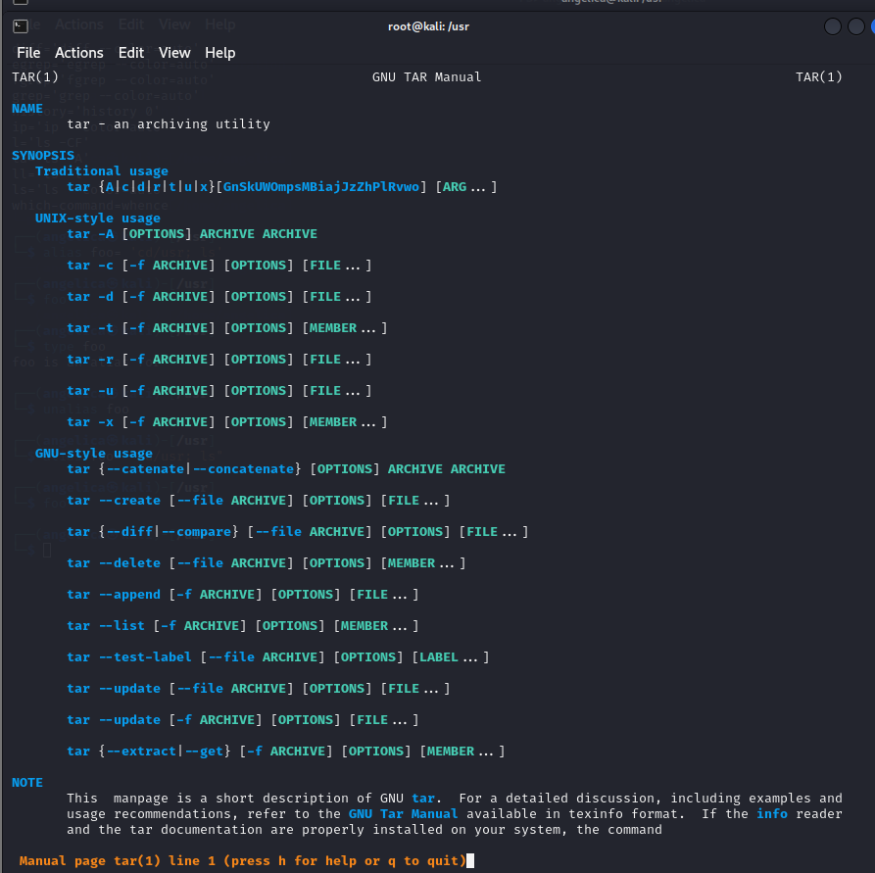

Task 3: Use info --help

1. What is the command to access the Info documentation for the “tar” command?



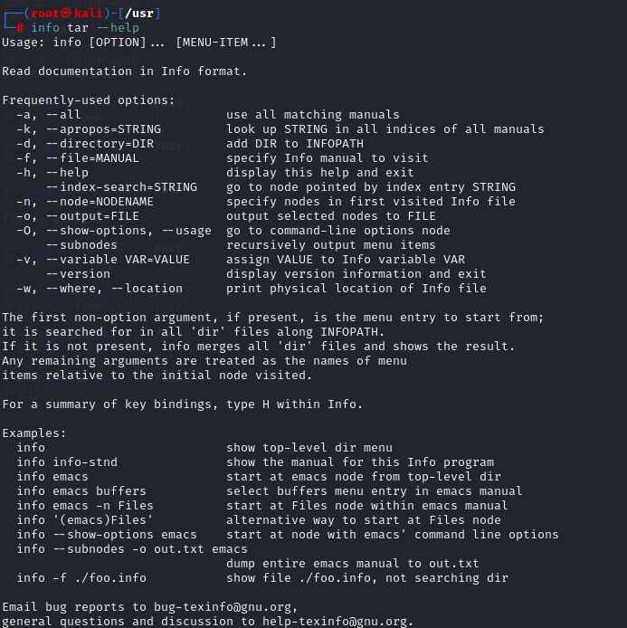

1. What command can you use to see a list of available info files?

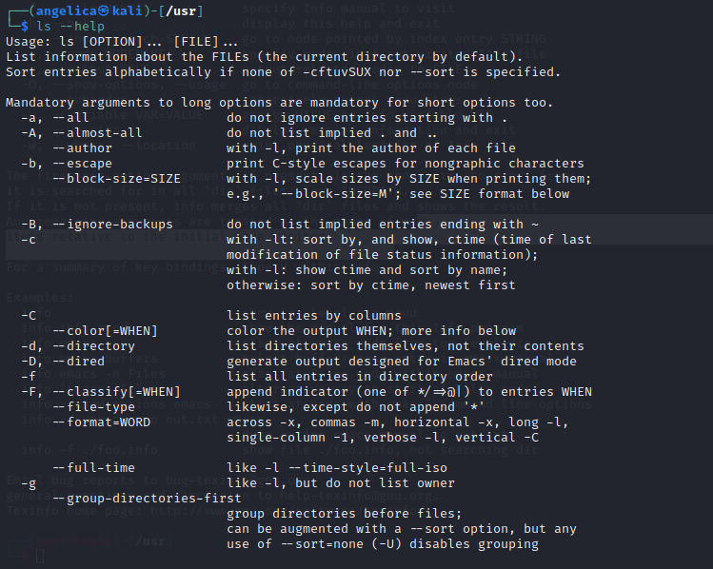

Task 4: Create an alias for a command of your choice, and provide a brief explanation of why you chose that command and how the alias will make it easier to use.

Alias md=’mkdir’

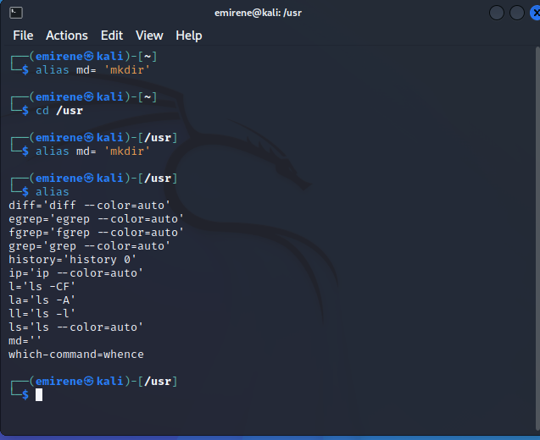

I choose this command because it allows users to create directories on the file system, making it a frequently used operation in Linux. In Linux, creating directories is a key operation since it enables users to effectively arrange their programs and files. I went with "md," which stands for "Make Directory," because it is shorter than "mkdir" and will make it simpler and faster for people to execute this command. It saves time and makes using such a command in specified situations simpler.